|  |  |  |
| --- | --- | --- |
| **LAB221Assignment** | **Type:** | **LongAssignment** |
| **Code:** | **J2.L.P0002** |
| **LOC:** | **500** |
| **Slot(s):** | **8** |

**Title: Mini Mart Management Software**

**Background**

A mini-mart is a small store that stocks a range of everyday items such as groceries, snack foods, milk, candy, toiletries, soft drinks, tobacco products, …Usually, its owner is a family, but some series of mini-martsare owned by a company such as VinMart (http://vinmart.vn/), 7‑Eleven (<https://www.7-eleven.com/>).

**Program Specifications**

The **Mini Mart Management Software** is widely accepted in cash transactions, where sale happens on the counter with immediate addition & subtraction in stock, multiple bills together, multiple screen working, bar code system, POS system and many other segments.

Basically, there are two groups of user in the system:

* Admin group: The owner of the store. There is only one Admin user in this group.
* Seller group: The sale staff

Each user is provided a user name and password to access the system. The user can change password. The admin can reset password of any user, and can change the group of a user.

**Features:**

1. User management :

- Full control of users(Add, Edit and Delete)

- Set role to user for accessing the system

1. Product management :

- Full control (Add, Edit and Delete)

- Product Info (Id, Name, Category, UnitPrice, Packaging, …)

1. Product category management : Full control Category(Add, Edit and Delete)
2. Billing: Create bill, view bill

**Permission**:

* Admin can use features: 1, 2,3
* Seller can use features: 4

**In this project, dealing with the bar code system and POS system are out of scope.**

***Expectation of User interface:***

The user interfaces should be simple, familiar with normal user. The languages are Vietnamese, English.

**Guidelines**

**Database design**

The database of the system should have the following entities and relationships:

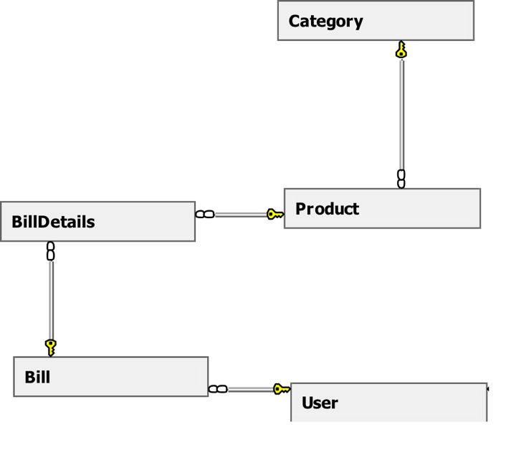

**Multi-language support**

To run any GUI of java application in multiple language java.util.ResourceBundle is used.